Experiment 6

File Creation and Download Commands
Aim
To execute touch, pwd, and wget commands.
Procedure
1. Create a file using touch.
2. Display current directory using pwd.
3. Download a sample file using wget.
Output
touch Command
Creates an empty file.
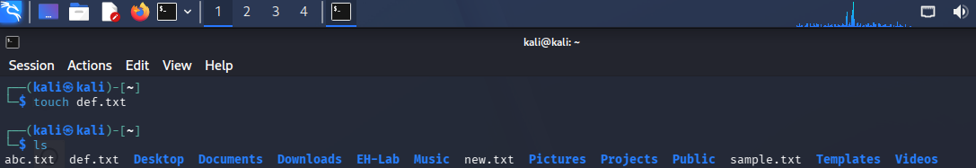
pwd Command
Displays current working directory.

wget Command
Downloads files from the internet.
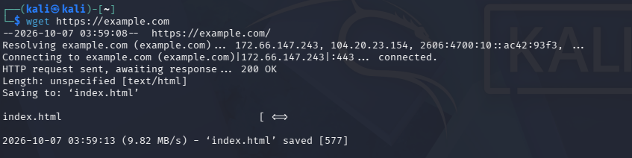

Result
Successfully executed touch, pwd, and wget commands

